DEVELOPMENT OF BI-DIRECTIONAL AC-DC CONVERTER MODULE
FOR IMPLEMENTATION IN POWER SYSTEM EDUCATION
Electrical Engineering and Computer Science MA17094 Fatin Ilyani binti Jefri
Power System Engineering Supervisor Prof. Dr. Goro Fujita
- Introduction
In recent decades, electrical utilities and many manufacturing industries conduct revolutionary development on power electronics, control system and also fast communication. Some of the main issues are related to renewable energy, flexible AC transmission systems and high voltage DC transmission [1]. In 2008, Future Renewable Electrical Energy Delivery and Management (FREEDM) system was established with purpose to create a modern power grid. Solid State Transformer (SST), one of the devices in FREEDM system, is a combination of AC-DC converter, DC-DC converter and DC-AC converter. It can convert both AC and DC to either AC or DC and get many attention and been extensively investigated for the distribution system. Thus, it requires power engineers and system planners to confront with this new technology development and understand both power electronics and the impacts of the device towards the network grid. However, for the students, it will be a tough challenge for them to have a solid understanding in power system engineering, or at least to have some understanding on how those fundamentals are implemented to the actual systems. Therefore, the purpose of this study is to develop a bi-directional AC-DC converter module for SST application in lab-scale size to help the students to gain deep understanding in this power electronics device.
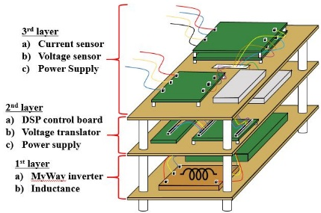
As control design is also the main important part in development of a device, this study also proposed to use Embedded Coder Toolbox which provided by MATLAB/Simulink. The implementation of this toolbox in the converter module will help the process of designing of controller becomes easier. Besides that, for power system education, the students will understand the control method used without deep understanding in C language which usually been used in the conventional control design. With the advantages of small size, compact and easy to handle, this module is believed can improve in knowledge of the students in the power system education.

- Solid State Transformer
As SST is the combination of three power electronics devices, a lot of transformation will be conducted before the power is transferred to the load. Figure 1 shows the configuration of SST.
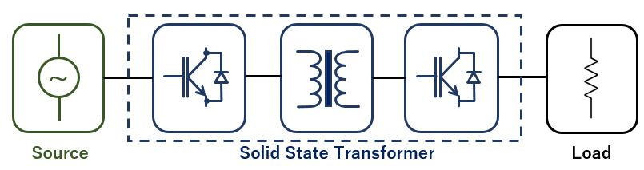

Figure 1. Configuration of SST

As conventional transformer needs to use same frequency for input and output, SST can use different frequency at the both sides. Moreover, for conventional transformer, it has fixed voltage ratio, while, the voltage ratio for SST is flexible. SST also can use both AC and DC as the input and output, thus, it makes SST is more convenient for the smart grid application. However, as for the efficiency, the highest efficiency can be reached by SST is 98.7% which is slightly lower than the conventional transformer, 99.5% [2]. This is because, since SST is the combination of many devices, the losses are produced in each device, thus, it will affect the overall efficiency of SST.

- Configuration of Bi-Directional AC-DC Converter Module
Even though the proposed design for AC-DC converter is in lab-scale size, the basic requirements for the usual AC-DC converter also need to be fulfilled. The requirements such as bi-directional power transmission, unity power factor, voltage regulation for output DC link and high efficiency are the main issues that are been focused during the development of this bi-directional AC-DC converter module. Figure 2 is the proposed design and suggestion development for bi-directional AC-DC converter module. This AC-DC converter module includes MyWay inverter MWINV-1R022 that has bi-directional capability, DSP control board TMS320F28335 Experimental Kit which functions as the control platform, power supplies (+24V, 12V, and +5V), current sensor, voltage sensor and also inductances that will help to eliminate the noise produced by the device.

Figure 2. Bi-directional AC-DC Converter

- Experimental Setup
- Control System Design
In this study, DSP control board TMS320F28335 Experiment Kit is used as the platform for the control system inside AC-DC converter module. During the designing of converter’s controller, instead of conventional method by using C language, MATLAB/Simulink provides a toolbox that can make the design for embedded system becomes more easy, which called as Embedded Coder Toolbox. Based on the control system designed in Simulink, the code which that be used by DSP control board will be automatically generated and it also can be modified via visual windows.
Figure 3 shows the control method used in the DSPF28335 Experiment Kit. First, voltage values are obtained from line voltages,$v_{abc}$. These values are used for transformation of abc to dq-frames. Line currents $i_{abc}$ which are transformed into dq-frames, are compared with dq reference currents. d-axis reference current $i_{d}^{*}$ is obtained by comparing dc reference voltage $V_{dc}^{*}$ and actual dc voltage $V_{dc}$. On the other hand, q-axis reference $i_{q}^{*}$ is set to ‘0’ in order to provide unity power factor. The difference between dq current and dq reference current are controlled by using PI controller for each frame. Then, the new dq switching functions are transformed into abc-frames and they are sent to PWM block to provide pulses for power switches of AC-DC converter.
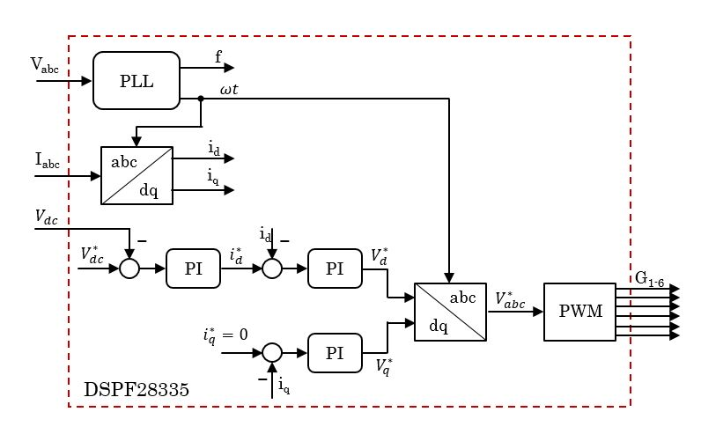

Figure 3. Control system used in DSP28335

- Experimental Test: Rectifier Mode
The experiment to test the designed control system is conducted with the whole configuration of AC-DC converter module which are MyWay inverter, DSP control board, power supplies, voltage sensor, current sensor and also inductances. Figure 4 shows the diagram of the experimental test.
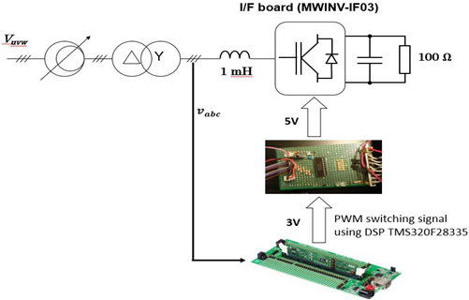

Figure 4. Diagram of experimental test

As shown in Figure 4, three phase of input voltage, v_{uvw} is regulated by voltage regulator and flown passed through delta-wye transformer which is used for isolation in this experiment. Then, by using voltage sensor, v_{abc} is measured and flown to DSP control board for the calibration, development of phase-locked-loop (PLL) and switching configuration, sPWM. The output of the DSP control board is the switching signals which are used by MyWay inverter. Since the output voltage of DSP control board is 3.3V and MyWay inverter can operate in 5V, a voltage translator board is required in this experiment.
AC input voltage is 20V with switching frequency for MyWay inverter is set to 20kHz. The DC reference value is set to 50V and the DC output voltage, $V_{o_dc}$ is recorded. The values for proportional gain, k_{p} and integral gain, k_{i} for both voltage and current are shown in Table 1.

Table 1. List of Parameters Used for PI Controller
Parameters | Value for controllers
Current controller | k_{p} | 1
 | k_{i} | 10
Voltage controller | k_{p} | 0.1
 | k_{i} | 1

- Experimental Test: Inverter Mode
As bi-directional power transmission also is one of the requirements in the AC-DC converter module, experimental test to confirm the power transmission in DC-AC conversion mode is conducted. The experimental configuration is slightly the same with Figure 4 but at the DC side of the converter, DC power supply is added. Besides that, for the control system, only current controller is used and by setting the $i_{d}^{*}$ to ‘-1’, the d-axis current, $i_{d}$ is observed. For the experimental test in inverter mode, voltage DC power supply, $V_{dc}$ 50V and three phase grid voltage, $v_{abc}$10V are implemented.

- Experimental Results
In rectifier mode, the DC output voltage, $V_{o_DC}$is measured by using a digital multimeter. While, to check the d-axis current $i_{d}$, a display in Simulink is used. In addition to that, by using power quality analyzer (PQA), power factor and total harmonics distortion (THD) for current and voltage are measured. The efficiency for each mode also been calculated. Table 2 shows the results of the experimental test in rectifier and inverter mode. Based on the results, in rectifier mode, the DC output voltage followed DC reference value which is 50V. Besides that, in inverter mode, d-axis current is near -1 and it can be confirmed that bi-directional power transmission for AC-DC converter is possible. Furthermore, it also can be confirmed that the designed voltage and current controllers are work successfully.

Table 2. Experiment Results
Parameters | Measured Value
 | Rectifier Mode | Inverter Mode
$$V_{o_DC}$$ | 50.45 V | -
$$i_{d}$$ | - | -0.9992
Power factor | 0.989 | 0.984
Voltage THD | 1.6% | 3.6%
Current THD | 7.8% | 7.3%
Efficiency | 89% | 86%

- Conclusion and Future Plans
For the conclusion, the AC-DC converter module satisfies the requirements needed which are bi-directional power transmission, unity power factor, voltage regulation for output DC link and has acceptable efficiency. Furthermore, the experimental test in high voltage range need to be conducted in order to confirm the performance of the developed AC-DC converter module. DAQ which functions as the control platform for all converters in SST also need to be designed.

References
[1] C.P. Vineetha, C.A. Babu: Smart Grid Challenge, Issues and Solutions, 2014 International Conference on Intelligent Green Building and Smart Grid (IGBSG), June 2014
[2] J.Kolar and J. Huber, “Solid state transformers-key design challenges applicability and future concepts”, 8th Int. Power Electron. And Motion Control Conf., Hefei, China, 2016

Research Achievements
F.I. Jefri, G. Fujita: PI Control System for Input Current of Active Rectifier is SST, The 5th International Conference of Electrical, Electronics and Information Engineering (ICEIE 2017), Malang, 6-10 October 2018
F.I. Jefri, N.D. Dinh, G. Fujita: PI Control System for Unity Power Factor of Active Rectifier in Solid State Transformer, South East Asian Technical University Consortium Symposium (SEATUC), Yogyakarta, 12 March 2018.
F.I. Jefri, M.S. Turiman, N.D. Dinh, G. Fujita: Development of Active Rectifier in Solid State Transformer by Using Embedded Coder Toolbox, The 11th Vietnam-Japan Scientific Exchange Meeting (VJSE 2018), Sendai, 15 September 2018

